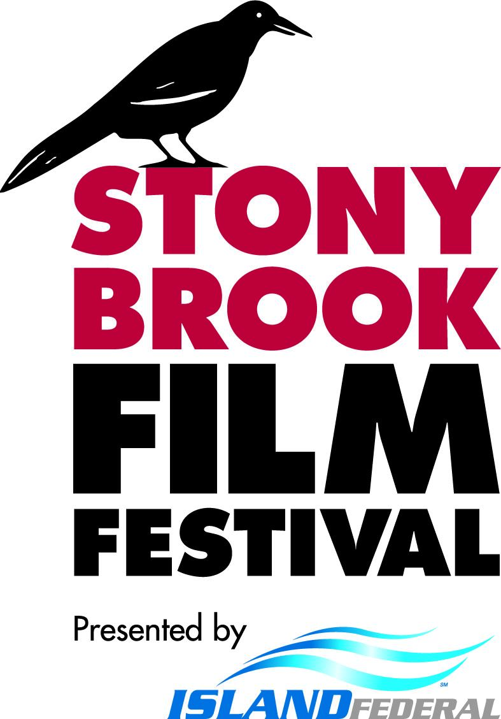

Contact: Samantha Clink | (631) 632-7233

Samantha.Clink@stonybrook.edu

[Stonybrookfilmfestival.com](http://stonybrookfilmfestival.com)

[FESTIVAL PHOTOS HERE](https://www.flickr.com/photos/stallercenter/albums/)

[FESTIVAL WINNERS HERE](https://stonybrookfilmfestival.com/winners/)

**[PRESS RELEASE]: WINNERS - 29th Annual Stony Brook Film Festival**

July 29, 2024, Stony Brook, NY - The Stony Brook Film Festival, presented by Island Federal, is excited to announce the [winners](https://stonybrookfilmfestival.com/winners/) of its 29th Annual Festival awards.

The festival at the Staller Center for the Arts brought together hundreds of directors and filmmakers and featured 36 films from 19 countries. Of the selected 36 films, 13 standouts received awards. This year’s festival was a record-breaking festival in a lot of ways. From the most awards given, including two rare awards, some of the youngest award-winners in festival history, and a documentary film taking home the grand prize, the second time ever in the 29-year history of the festival, to the best-attended festival since well before covid, the 29th Annual Festival was a huge success.

**MEDIHA** took home the **Grand Prize Award**. Directed by Hasan Oswald, this masterful documentary chronicles the journey of a young Yazidi girl returning from ISIS captivity. Using her camera to process her trauma, she documents her experience while rescuers continue to search for her missing family members. The film vividly illustrates the extraordinary endurance of the human spirit and the critical need to amplify the voices of those who have been unheard for too long. The Grand Prize is given to films that have ‘wowed’ both the audience and the jury beyond what could be contained in the simple phrase ‘best film’ in this or that category. *Mediha* is the 11th film in the festival's 29-year history that has received a Grand Prize and only the second time awarded to a Documentary Film. Former winners include *Anchorage*, *Chuskit*,and Academy Award-winning *West Bank Story***.**

Mediha and Oswald attended their Wednesday night screening, but only Mediha could accept the award on closing night. Oswald wrote to the jury about receiving the Grand Prize:

*"Thank you to my partner in crime, Mediha, for making this film with me ... I also want to thank the jury for their support as well as this superb audience for giving us our largest crowd yet. In closing, I want to thank all of you once again for giving this film and this cause the platform it so badly needs. Next week marks the ten-year anniversary of the Yazidi genocide, and while bringing awareness back to what happened to the Yazidis is paramount, I would be remiss if I didn't acknowledge that Mediha and her brothers also embody the human cost of conflict, worldwide. Your support tonight and this past week helps ensure their voices are heard and we as a society are unable to use naiveté as an excuse for inaction. Thank you".*

Two short films won the audience's hearts, resulting in a tie for this year's **Audience Choice Award for Best Short.** The winners for this category included two of the youngest filmmakers to win an award in the 29-year festival history. **MIMESIS**, a drama about a struggling alcoholic actor who finds solace in an audition for the role of therapist, and **ON THE PATHS AWAKENED**, a WWII-era story of two French teens facing intimate conflicts as the resistance recruits them. The festival's youngest filmmakers directed the two winning short films: 20-year-old Zach Finger from Long Island and 19-year-old Axel Dahan from France.

One feature that truly captivated the audience was **RUNNING ON SAND**, which took home the **Audience Choice Award for Best Feature**. Adar Shafran directed this heartfelt crowd-pleaser about a refugee from Israel who, facing imminent deportation, is mistakenly identified as a Nigerian soccer star at the airport. The film highlights the precariousness of refugees' lives, the power of second chances, and the complex intersections of identity and survival.

**The Spirit of Independent Filmmaking Award** is for filmmakers who use a distinct indie perspective to bring their stories to life vividly. It is reserved for filmmakers who have created a standout film with very few resources, financial or otherwise. *"When it looks and sounds great, plays great, creates its own world, and you would never suspect how hard the filmmakers worked to bring it to life on screen, then you're watching the kind of film we give these awards to,"* says Festival Programmer, Kent Marks. **DAUGHTER OF THE SUN** secured the honor of this year's Spirit of Independent Filmmaking Award. This vintage-feeling, breathtaking fantasy tells the story of a man with Tourette's Syndrome and supernatural powers and his 12-year-old daughter navigating life on the run. Producer Mackenzie Leigh and Director/Actor Ryan Ward accepted the award at the festival ceremony, and Mackenzie announced from the stage:

*"I think being an artist and being a filmmaker, you have ideas that are just in your head, and you mobilize people and resources to build a big house of cards to make something happen in reality. And I think that's what happens with this festival every year too. We are so thankful to be able to come here and take part in your dream. You have something so special here; for all of you who donate and come and participate, it means so much to filmmakers worldwide. You are making a big difference for artists from all over the world. Thank you."*

The festival also announced that one of the films received an especially rare award in the **2024 Dr. Gabriel Sara Humanitarian Award**. In 2022, the Stony Brook Film Festival created an inaugural prize in honor of Dr. Gabriel Sara, who worked wonders in cancer at Sloan Kettering in NY by treating patients with dignity through song, dance, and teaming up with some of the most caring individuals in healthcare. He went on to play a role not unlike himself in the film opposite Catherine Deneuve. This year, the festival hosted a sneak preview of a film that's having its official premiere in the fall, but Stony Brook Film Festival was able to host it as a non-competing sneak preview of the film. The film **AUDREY'S CHILDREN** tells the story of Dr. Audrey Evans, who brought new treatments to pediatric cancer patients in the US and went on to co-found The Ronald McDonald House.

*"When I reached out to Gabriel Sara in Lebanon to tell him we were bestowing this award to* ***Audrey's Children****, he was overjoyed, saying that Audrey Evans is a legend in cancer research and treatment and he so wished he could be here to present the first GABRIEL SARA HUMANITARIAN AWARD since creating it in his name to AUDREY'S CHILDREN,*" announced Festival Director Alan Inkles from the Awards stage. The film was directed by Ami Canaan Mann, written and produced by Julia Fisher Farbman and produced by Bradley Gallo and Michael Helfant. Gallo was in attendance to accept the award on behalf of his team. The film was not in competition with any of the other 35 films in the festival. Still, the jury felt it deserved recognition because of the groundbreaking story it tells, the unmatched heroism of the real-life characters, and the unbelievable humanitarian efforts of Dr. Audrey Evans. ***Audrey's Children*** will premiere this fall.

Other awards include the **Jury Award for Directing** given to **MASTERGAME**, the **Jury Award for Best Short** for **WHERE WE BELONG**, and the **Jury Award for Best Feature** for **THE STRANGERS' CASE**. The Jury Awards are all a joint decision that all festival jury members must agree on. The jury may have an idea of what films are in consideration before they play at the festival because they have all been pre-screened. Still, decisions are only made once they are viewed by the jury a second time alongside the live audience.

**The Jury Award for Directing** is another rare award for the Stony Brook Film Festival to bestow only when the situation warrants it. Sometimes, the jury has more truly outstanding films for which they have awards, and when this happens, they discuss whether there is a way to recognize what impacted the jury so much. Sometimes it is the message, sometimes it might be an actor, and sometimes the jury realizes it was the vision and artistry of the director - which was the case this year with **MASTERGAME**. This is the second film the festival has had from Director Barnabás Toth, and both were simply masterful.

Toth attended the Awards Ceremony and said, *"Being here as a filmmaker is special ... coming here is like a therapy, a cure for any kind of artist because people who create are appreciated here. So please continue to keep it that way. Thank you for this award."*

Director Madoka Yamamoto of **WHERE WE BELONG** received the **Jury Award for Best Short** but could not return for the Awards Ceremony in person. She sent her regards, stating: *"We could've never imagined that our short film would travel all the way from London to New York. This story was inspired by my own experience growing up outside Japan, but I'm so happy this has resonated with many people outside of the Japanese community. Thank you, Stony Brook Film Festival, for supporting the work of emerging filmmakers and giving us that space."*

Director Brandt Andersen was in attendance for the Q&A of his film and sent a note upon learning of **THE STRANGERS' CASE** winning the **Jury Award for Best Feature**. *"Thank you to the Stony Brook jury for this honor, and a special thank you to the audience at Stony Brook. There are moments in life when the amount of time spent together is not equal to the connection felt. This was how we felt at Stony Brook. I hope you experienced this while watching our film."*

The Festival's Opening and Closing Night Feature and Short films were also recognized, including Director Aexandre Arcady of THE BLOND BOY FROM THE CASBAH (Opening Night Feature), Christopher Doll, Director/ Producer and Karoline Herfurth, Actress of ONE MILLION MINUTES (Closing Night Feature), Daniel Rashid, Director of CHAUNCEY (Opening Night Short), and Tathagata Gosh, Director of IF (Closing Night Short). All 13 awards are listed below.

[**2024 FESTIVAL WINNERS**](https://stonybrookfilmfestival.com/winners/)

[**MEDIHA**](https://stonybrookfilmfestival.com/winners/)

[**2024 GRAND PRIZE**](https://stonybrookfilmfestival.com/winners/)

[**THE STRANGER’S CASE**](https://stonybrookfilmfestival.com/winners/)

[**2024 JURY AWARD FOR BEST FEATURE**](https://stonybrookfilmfestival.com/winners/)

[**WHERE WE BELONG**](https://stonybrookfilmfestival.com/winners/)

[**2024 JURY AWARD FOR BEST SHORT**](https://stonybrookfilmfestival.com/winners/)

[**DAUGHTER OF THE SUN**](https://stonybrookfilmfestival.com/winners/)

[**2024 SPIRIT OF INDEPENDENT FILMMAKING**](https://stonybrookfilmfestival.com/winners/)

[**MASTERGAME**](https://stonybrookfilmfestival.com/winners/)

[**2024 JURY AWARD FOR DIRECTING**](https://stonybrookfilmfestival.com/winners/)

[**AUDREY’S CHILDREN**](https://stonybrookfilmfestival.com/winners/)

[**2024 DR. GABRIEL SARA HUMANITARIAN AWARD**](https://stonybrookfilmfestival.com/winners/)

[**RUNNING ON SAND**](https://stonybrookfilmfestival.com/winners/)

[**2024 AUDIENCE AWARD FOR BEST FEATURE**](https://stonybrookfilmfestival.com/winners/)

[**MIMESIS** & **ON THE PATHS AWAKENED**](https://stonybrookfilmfestival.com/winners/)

[**2024 AUDIENCE AWARD FOR BEST SHORT**](https://stonybrookfilmfestival.com/winners/)

[**ONE MILLION MINUTES**](https://stonybrookfilmfestival.com/winners/)

[**2024 CLOSING NIGHT FEATURE**](https://stonybrookfilmfestival.com/winners/)

[**IF**](https://stonybrookfilmfestival.com/winners/)

[**2024 CLOSING NIGHT SHORT**](https://stonybrookfilmfestival.com/winners/)

[**THE BLONDE BOY FROM THE CASBAH**](https://stonybrookfilmfestival.com/winners/)

[**2024 OPENING NIGHT FEATURE**](https://stonybrookfilmfestival.com/winners/)

[**CHAUNCEY**](https://stonybrookfilmfestival.com/winners/)

[**2024 OPENING NIGHT SHORT**](https://stonybrookfilmfestival.com/winners/)

*Island Federal's generous role as the presenting sponsor makes the Stony Brook Film Festival possible. Additional support comes from News 12 Long Island; Campolo, Middleton & McCormick, LLP; Suffolk Arts and Film; Strata Alliance; and WLIW/PBS. We sincerely thank all of our sponsors, members, and donors.*